Student name:____________________________

Student number: ___________________________

Worksheet #1: Genes, chromosomes & cells

**1.** Your friend says that the cell shown below contains four diploid chromosomes. Is your friend correct? Please explain fully why or why not. **(2 marks)**

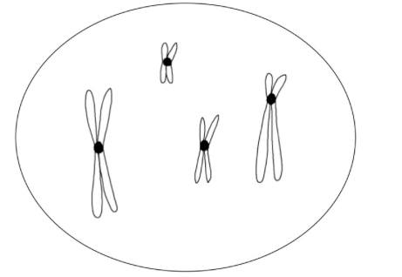

*Insert your answer here:*

**2.** Please explain, in your own words, the difference between the terms diploid vs. replicated as they relate to chromosomes. **(2 marks)**

*Insert your answer here:*

**3.** Draw a diagram of a eukaryotic cell that satisfies the following criteria: **(3 marks)**

* The cell is diploid, and contains a total of six chromosomes and 12 DNA molecules
* Two of the chromosomes have centromeres closer to one end of the chromosome
* The remaining chromosomes have centromeres approximately in the middle of the chromosome; two of these chromosomes carry a gene identified as “B”

*Insert your answer here:*